Independent SAGE Behavioural Advisory Group
Team Meeting Minutes
Time/Date/Location: 5.30pm-6.45pm BST - 23/06/2020 via Zoom
Attendees: Val Curtis, John Drury, Ann Phoenix, Steve Reicher, Liz Stokoe, Robert West, Laura Bear, Susan Michie.

Agenda
1. Minutes
2. Action points and matters arising
3. Distancing changes
4. Equalities
5. Overall strategy statement
6. AOB +
- Minutes
No edits to the minutes. All action points completed.
- Action points and matters arising
Agreed on the use of Google Drive for general operations. Everyone to set up Gmail account. Key documents will also be uploaded to Dropbox for wider IndieSAGE consumption.
- Distancing changes
Discussion around availability of data and difficulties around getting infection and death rates from government information.
Need a clear overall strategy argument which explains that we want to get to a proper reopening as soon as possible and outlines the what needs to be done to achieve that.
Values: we need to have a hierarchy of values and what it is most valuable to prioritise in the process of opening up. We need to articulate our values and we want the government to do the same so that people can see who is prioritising what.
Overall, we support the release of an overall strategy document, but it must include a clear articulation of priorities, values and timings.
- Equalities
There was a discussion of the diagram produced by Val Curtis (with Laura Bear and Robert West). It was agreed that, while the diagram does not exhaustively depict all the relevant causal paths, it provides a powerful schematic for representing the multi-factorial determination of greater infections and deaths in BME communities, for showing the links between different pathways and for deriving practical interventions. Moreover, rather than suggesting that all BME groups are affected in the same way, it is a basis for analysing how different groups are impacted in different ways.
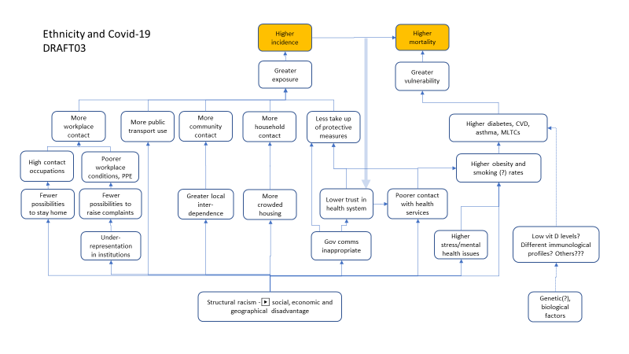
It was agreed that Robert West would redraw the diagram using a more user-friendly format (with input from everyone by Weds 24th 5pm) and that it should be accompanied by a preamble to be written by Laura Bear by Friday 26th 5pm with inputs from others by Thursday 25th lunchtime. The preamble should cover the following points about the purpose of the diagram:
- To show the connectedness between the different pathways.
- To show the key behavioural precursors on which interventions can be made.
- To be a tool to think about how COVID-19 impacts on different groups, rather than a one-size-fits-all approach to ‘BAME’*.
- To help in producing specific recommendations about interventions and the need for research.
- To represent the likely impacts of each new lockdown/easing measure at different points in the model.
- To be a Version 1.0 for feedback and public consultation.

It was agreed that, with these changes, the document should be proposed to Independent SAGE as a complement to the main equalities document and that amendments should be made to the main document which (i) give greater stress to the impact of structural racism, and (ii) make clearer the multiple pathways and links between them. Two other issues were raised regarding the Independent SAGE document. First, the need to consider terminology, the problems of the term BAME obscuring differences between groups, and the danger of it normalizing whiteness. Second, in terms of practical recommendations, the need to build an equalities audit into all policy proposals and the need for co-creation of policies involving members of minority communities.
- Overall strategy statement
This was addressed in the matters arising from the minutes. It was agreed to support an overall strategy statement, along with a statement of values and priorities for new measures.
- AOB
Laura Bear raised the issue of a statement on shielding and stressed the following points:

- People who are shielding have been told they can return to work in “COVID-safe” environments; enabling a “choice” to work.
- This will occur alongside tapering support schemes from various sources, which will also be reduced after the date of return to work.
- Independent SAGE is concerned about the withdrawal of support, which has been inadequate anyway, but also that people will be pushed into workplaces that may not be safe.
- The structural inequalities that are captured in the Ethnicity and Covid-19 iSAGE BAG Model equally apply to ‘shielding’ groups, intensifying mortality.

It was agreed that John Drury would draft a statement by Thursday 25th lunchtime and this would be forward to Independent SAGE to get their support by Friday 26th.

Action points | Person | Deadline
Set up Gmail account | Whole team | 30/06/2020
Set up Google Drive folders | Savannah | 30/06/2020
Send chart comments to Val and Robert | Everyone | 5PM - 24/06/2020
Update chart | Robert supported by Savannah | 5PM – 26/06/2020
Shielding Statement | John | 25/06/2020
Preamble draft- send to BAG | Laura supported by Robert | 5PM - 24/06/2020
BAG to submit | Steve | 5PM – 26/06/2020
Get 1m vs 2m report on website | Steve | 30/06/2020

